МИНИСТЕРСТВО ОБРАЗОВАНИЯ И НАУКИ РОССИЙСКОЙ ФЕДЕРАЦИИ

ФЕДЕРАЛЬНОЕ ГОСУДАРСТВЕННОЕ АВТОНОМНОЕ ОБРАЗОВАТЕЛЬНОЕ УЧРЕЖДЕНИЕ ВЫСШЕГО ОБРАЗОВАНИЯ «САМАРСКИЙ НАЦИОНАЛЬНЫЙ ИССЛЕДОВАТЕЛЬСКИЙ УНИВЕРСИТЕТ ИМЕНИ АКАДЕМИКА С.П. КОРОЛЕВА»

Институт информатики и кибернетики

Дисциплина: «Инженерия программного обеспечения: DevOps»

Отчет по лабораторной работе №4

«Prometheus + Grafana»

Выполнил:

студент группы 6412-100503D

Правдин И.Д.

Самара 2023

# Goals of the work

1. Setup Prometheus and grafana
2. Deploy mongodb application and mongodb exporter.
3. Create/use existing dashboard for mongodb metrics and explore graphics.

# Prerequisites

I will use minikube vm that was created for assignment №1 in this course.

# Installing Prometheus

I have used community helm chart for Prometheus and Grafana, so next instructions install Prometheus and Grafana to cluster

|  |
| --- |
| helm repo add prometheus-community <https://prometheus-community.github.io/helm-charts>  helm repo update  helm install prometheus prometheus-community/kube-prometheus-stack |

# Installing Sample App for scrape metrics

As sample app I used mongo database as main application and mongo exporter for scrape metrics from database. For deploy main application I used next yaml k8s manifest:

|  |
| --- |
| apiVersion: apps/v1  kind: Deployment  metadata:  name: mongodb-deployment  labels:  app: mongodb  spec:  replicas: 1  selector:  matchLabels:  app: mongodb  template:  metadata:  labels:  app: mongodb  spec:  containers:  - name: mongodb  image: mongo: 4.2.24-rc0  ports:  - containerPort: 27017  ---  apiVersion: v1  kind: Service  metadata:  name: mongodb-service  spec:  selector:  app: mongodb  ports:  - protocol: TCP  port: 27017  targetPort: 27017 |

For deploy mongo exporter I used communities helm chart with next values:

|  |
| --- |
| # values.yaml  mongodb:  uri: "mongodb://mongodb-service:27017"  serviceMonitor:  enabled: true  additionalLabels:  release: prometheus |

Command:

|  |
| --- |
| helm install mongodb-exporter prometheus-community/prometheus-mongodb-exporter |

# Exploring metrics

For explore metrics I used community created Grafana dashboard, so I just import json from <https://grafana.com/grafana/dashboards/14997-mongodb/> site.

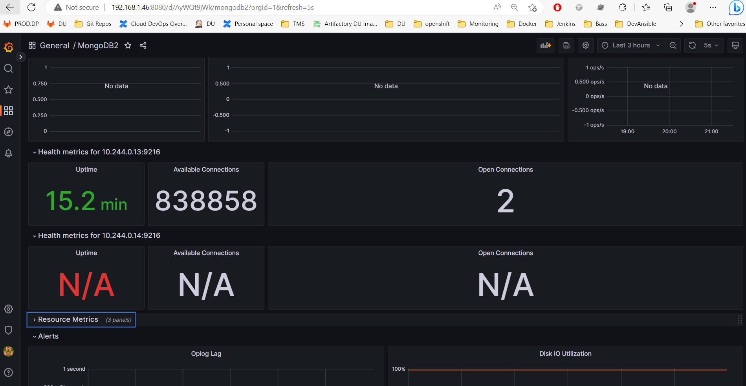  
Proof screenshot